Test Case One

Test Case ID: TC001

Test Case Title: View and Add Car Item

Description: Verify that a car item can be viewed and added successfully.

Preconditions: The application is open and has at least one car item in the catalogue.

Inputs:

- Car Item ID: 123 (Assuming this is a valid ID in the catalogue)

- Car Item Make: Toyota

- Car Item Mileage: 25000

- Car Item Registration: XYZ123

- Car Item VRT: 1500.00

- Car Item Price: 18000.00

Expected Outcome: The car item with ID 123, Car make, Mileage, Registration, VRT, and Price should be viewed and added successfully to the catalogue.

Steps:

1. Open the application.

2. Ensure there is at least one car item in the catalogue.

3. Click the "View" button.

4. In the GUI:

- Remove the displayed text in the Text field.

- Type "123" as the Car Item ID.

- Make: [Displayed Make]

- Registration: [Displayed Registration]

- Price: [Displayed Price]

- VRT: [Displayed VRT]

- Mileage: [Displayed Mileage]

- ID: [Displayed ID]

8. Press the "Add" button to store the car item.

9. Press the "View" button to view all car items.

10. Verify that the newly added car item with ID 123, Car item, price, mileage, price, registration, make, and VRT is displayed in the list of car items.

Actual Outcome: The car item with ID 123, Car item, price, mileage, price, registration, make, and VRT is displayed in the list of car items and is viewed and added successfully to the catalogue, and its details match the entered information.

Pass/Fail Criteria: Pass

Test case two.

Test Case ID: TC002

Test Case Title: Search Car Item by ID

Description: Verify that a car item can be searched and displayed successfully by entering its ID.

Preconditions: The application is open and contains at least one car item in the catalogue with ID 123 .

Inputs:

- Search Car Item ID: 123

Expected Outcome: The car item with ID 123 should be found and its details (Make, Mileage, Registration, VRT, Price) should be displayed in a dialog box.

Steps:

1. Open the application.

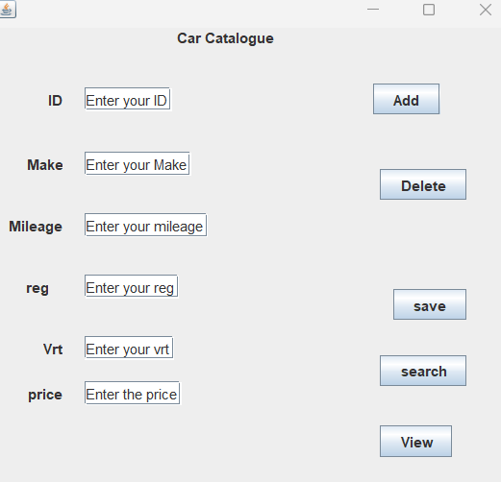

2. Ensure there is at least one car item in the catalogue with ID 123.

3. In the GUI:

- Enter "123" as to Search Car Item ID.

5. Press the "Search" button.



6. A dialog box should appear displaying the details of the car item with ID 123:

- Make: [Displayed Make]

- Mileage: [Displayed Mileage]

- Registration: [Displayed Registration]

- VRT: [Displayed VRT]

- Price: [Displayed Price]

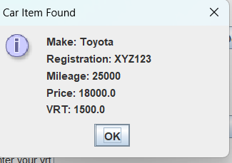

Actual Outcome: The car item with ID 123 is successfully searched, and its details match the expected information.

Pass/Fail Criteria: Pass

Test Case 3

Test Case ID: TC004

Test Case Title: Delete Last Added Car Item

Description: Verify that the last added car item can be deleted successfully using the Delete button.

Preconditions: The application is open and contains at least two car items in the catalogue.

Inputs: None

Expected Outcome: The last added car item in the catalogue should be deleted, and the updated catalogue should be displayed upon pressing the View button.

Steps:

1. Open the application.

2. Ensure there are at least two car items in the catalogue.

3. Press the "View" button.

4. Verify the current list of car items.

5. Press the "Delete" button.

6. Press the "View" button again to view the updated car items

.

7. Verify that the last added car item has been successfully deleted from the catalogue.

Actual Outcome: The last added car item is successfully deleted from the catalogue, and the updated catalogue is displayed upon pressing the View button.

Pass/Fail Criteria: Pass

Test Case 4

Test Case ID: TC004

Test Case Title: Save Car Item to Catalogue

Description: Verify that a newly added car item can be saved to the catalogue and retrieved for viewing.

Preconditions: The application is open.

Inputs:

- Car Item ID: 123

- Car Item Make: Toyota

- Car Item Mileage: 25000

- Car Item Registration: XYZ123

- Car Item VRT: 1500.00

- Car Item Price: 18000.00

Expected Outcome: The newly added car item should be successfully saved to the catalogue and should be viewable even after the application is closed and reopened.

Steps:

1. Open the application.

2. Enter the following information for a new car item:

- Car Item ID: 123

- Car Item Make: Toyota

- Car Item Mileage: 25000

- Car Item Registration: XYZ123

- Car Item VRT: 1500.00

- Car Item Price: 18000.00

3. Press the "Add" button to store the car item.

4. Press the "Save" button to save the car item to the catalogue.

5. Close the application.

6. Reopen the application.

7. Press the "View" button to view all car items.

8. Verify that the previously added car item with ID 123 is displayed in the list of car items.

Actual Outcome: The newly added car item is successfully saved to the catalogue and remains viewable even after the application is closed and reopened.

Pass/Fail Criteria: Pass

Test Case

Test Case ID: TC00Test Case Title: Automatically Load Saved Car Items on Application Start

Description: Verify that the application automatically loads previously saved car items and displays a dialog box upon application start.

Preconditions: The application is closed after saving a car item using the "Save" button.

Inputs: None

Expected Outcome: The application should display a dialog box indicating that previously saved car items are being loaded and then automatically display the loaded car items.

Steps:

1. Open the application.

2. Enter the following information for a new car item:

- Car Item ID: 123

- Car Item Make: Toyota

- Car Item Mileage: 25000

- Car Item Registration: XYZ123

- Car Item VRT: 1500.00

- Car Item Price: 18000.00

3. Press the "Add" button to store the car item.

4. Press the "Save" button to save the car item to the catalogue.

5. Close the application.

6. Reopen the application.

7. After loading, the application should display the loaded car item with ID 123 in the list of car items.

Also with the test output u should see text saying Car items loaded from file.

Car items loaded successfully.

Actual Outcome: The application displays a dialog box indicating the loading of previously saved car items and then automatically loads and displays the saved car item when the application is reopened.

Pass/Fail Criteria: Pass

Class Diagram.

